Chap 14: Travel time
Focal thoughts
- What is transportation
- Different vehicles
- Fuel
This is how Jay and his friends travel to school.
Illos and captions: Tina, Dia, Suraj and Ali travel by the school bus; Jay, Payal, Arush and Mini share a car ride; James walks down along with his mother; Tara’s father drops her in his scooter
Transportation (A head)
Every day we need to move from place to place. The movement of people and goods from one place to another is called transportation.
The way we travel improved once human beings made the wheel. Before the wheel was invented people had to walk long distances or ride on animals to travel from place to place.
Images: People travelling/Goods being carried
Different vehicles (A head)
Today, we use different modes of transport, such as, roadways, railways, waterways and airways.
Get the knowledge shower
One of the oldest types of transportation is by boat. Thousands of years ago, sea traders set out in small boats to trade goods in different parts of the world.
Cars, scooters, buses, auto rickshaws and trucks are some vehicles that help us to travel by road. Trains, metro trains and trams move on tracks build on the road. Ships, boats and yachts help us to travel and carry goods across rivers and seas. Aeroplanes, helicopters and space shuttles are used to travel by air.
Images: Collage of vehicles by road/rail/air/water
Airway is the fastest and the most expensive mode of transport.
Fuel (A head)
Vehicles such as cars and scooters need some fuel to make them move. Petrol, diesel and CNG are examples of fuel. The fuel burns and gives the vehicle energy to move.
We visit petrol pumps or CNG stations to fill fuel in our vehicles. It is important to save fuel. Image
When a fuel burns it gives out harmful smoke that makes the air dirty. Image
Human-powered and animal-powered vehicles (A head)
Vehicles such as cycles, rickshaws and hand carts are moved by human beings. They do not use any fuel. Such vehicles save fuel and keep the air clean. Images
Animals also help in transportation. Elephants carry logs and other loads in forest areas. Bullock, horse and camel carts are used in villages, towns and cities to carry people and goods. In hot, sandy deserts camels are the most important means of transport. Yaks and ponies help carry load in hilly areas where other vehicles cannot reach.
Recap and reinforcement zone
Word wagon
Fuel: A source of energy
Transportation: The movement of people and goods from one place to another
Recap shots
- The movement of people and goods from one place to another is called transportation.
- We use different modes of transport, such as, roadways, railways, waterways and airways.
- Vehicles such as cars and scooters need some fuel to make them move.
Work out
- Write ‘T’ for true and ‘F’ for false.
- Trains move on tracks. □
- Airway is the fastest and the most expensive mode of transport. □
- Fuels need not be saved. □
- Cycles and rickshaws need fuel to move. □
- Ships, boats and yachts help us to travel and carry goods across rivers and seas. □

- Name the following.
- Four modes of transport: ……………….., …………………, ……………………….., …………………..
- Two vehicles that help us to travel across rivers and seas: ………………………., ……………………..
- Two fuels used by vehicles: ………………., ………………..
- Two human-powered vehicles: ………………, ……………….
- Two animal-powered vehicles: …………….., …………………

- Answer the following.
- What is transportation?
- How did humans travel before the invention of the wheel?
- Why do vehicles need fuel?
Do and learn
Can you recognise these special vehicles? Talk about their importance.
- 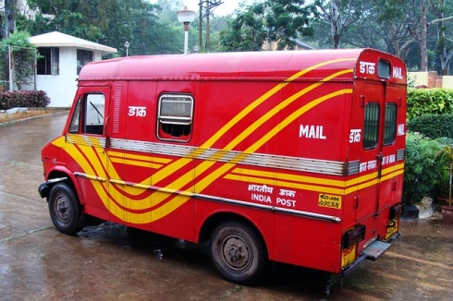 2. 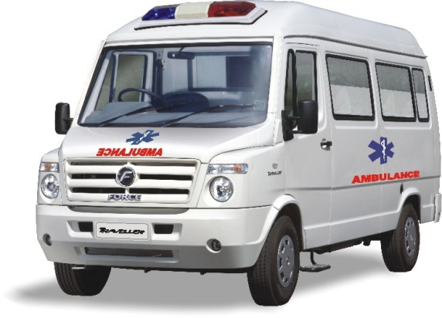
For the facilitator*
- Inculcate the need to save fuel by walking short distances or by cycling. Talk about the fact that Jay and some of his friends do a carpool, bringing out the significance of sharing a ride.
- Have quiz time on means of transport. Some sample questions:
- The fastest means of transportation is: a. cycle b. bus c. aeroplane d. helicopter
- The slowest means of transportation is: a. cycle b. bullock cart c. auto rickshaw d. car
* To initiate co-operative and individual learning

* To initiate co-operative and individual learning

Chap 15: Talk time
Focal thoughts:
- What is communication
- What are some means of communication
It is Dia’s birthday. Aunt Tina has called to wish Dia.
Illo: Conversation between Dia and her Aunt over the phone
Aunt Tina: Wish you a very happy birthday Dia!
Dia: Thank you Aunty.
Aunt Tina: Have fun with your friends. I will be back on Sunday. See you then.
Dia: Bye Aunty! Take care.
Communication (A head)
When people talk or write to one another it is called communication. We need to talk to people around us to:
- Tell them how we feel
- Share information or what we know
Means of communication (B head)
The different methods we use to communicate are known as means of communication.
Dia’s aunt was not in town. However, she could wish Dia on her birthday over the phone. The telephone and mobile phones are very useful means of communication.
Get the knowledge shower
India has one of the largest postal Service networks in the world.

Telephone is the fastest means of communication. Today, we can talk to people in far-off cities or even in different countries. Mobile phones help us to communicate even while we are travelling. Mobile phones are also used to send SMS. Images
Letters are the most common means of communication. Cities, towns and villages have post offices. We can buy postcards, inland letters, envelopes and stamps from the post office. We can also send parcels and money through money orders from the post office. This method of communication costs very little. The speed post can be used to send letters and other important mails quickly. Images
We can also send e-mail messages through the internet to any part of the world on the computers. Images
Fax machines help to send instant messages. Fax machines are connected through a telephone line. Images
Newspapers and magazines are also means of communication. They help us to gather and share information about different things. Images
The television and radio are good means of communication. We can hear news, music and many other programmes on the radio. We can watch and hear programmes on the television. Images
Every means of communication is useful in its own way. Together, they help us keep in touch with our friends, relatives and the world.
Recap and reinforcement zone
Word Wagon
Communicate: To talk or write to someone
Means of communication: Different methods we use to communicate
Recap shots
- When people talk or write to one another it is called communication.
- The different methods we use to communicate are known as means of communication.
- Telephones, mobile phones, letters, fax, newspapers, magazines, televisions and radio are all means of communication.
Work out
- Fill in the blanks.
newspapers stamps internet telephone postcards mobile e-mail

- Mobile phones help us to communicate even while we are travelling.
- We can buy postcards, inland letters, envelopes and stamps from the post office.
- We can also send messages by e-mail through the internet to any part of the world on the computers.
- Newspapers and magazines are also means of communication.
- Fax machines are connected through a telephone line.

- What is it?
- Helps us communicate even while travelling: ………………………..
- Can watch and hear programmes on it: …………………..
- The different methods used to communicate: ………………………
- To talk or write to one another: …………………….
- The message sent using the internet on a computer: …………………

- Answer the following.
- What is communication?
- Why do we need to communicate?
- What are some means of communication?
- How are newspapers and magazines useful?
- What is a fax message?
Do and learn
- Write a letter to a cousin who stays in another city or country. Take help from your parents to post the letter at the correct address.
- Name the means of communication.
- 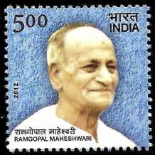 2. 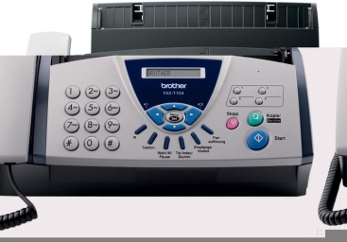 3.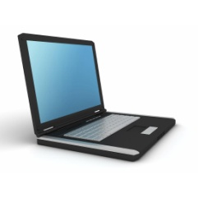
…………………… …………………………… ……………………
4.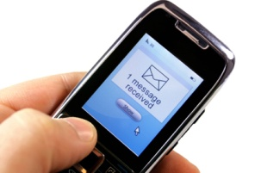5. 6. 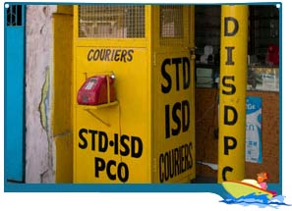
………………………………………………. ………………………………………………… …………………………………………….
For the facilitator*
- Talk about sign language and Braille. Touch upon the usefulness of these means of communication for us.
- Encourage children to share their observations on how animals communicate.
* To initiate co-operative and individual learning

* To initiate co-operative and individual learning

